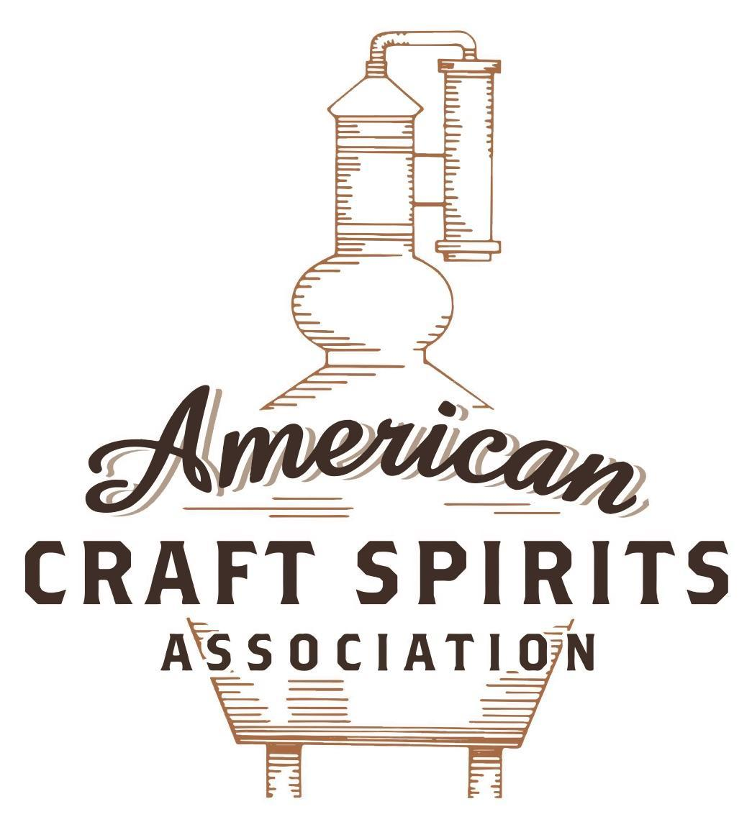
Spirits DtC Shipping Guide

This guide summarizes the direct-to-consumer shipping rules for distilleries in all 50 states and D.C. and also addresses the measures state governments have taken to ease delivery and shipping restrictions during the COVID-19 pandemic.

DtC Quick Guide Comparison

Out-of-State Distilleries  Can Ship Into State? |  |  |  | In-State Distilleries  Can Ship Within State?
State | Yes | No |  | State | Yes | No
AL |  | X |  | AL |  | X
AK | X |  |  | AK | X
AZ | X |  |  | AZ | X
AR |  | X |  | AR |  | X
CA |  | X* |  | CA |  | X*
CO |  | X |  | CO |  | X
CT |  | X* |  | CT |  | X
DE |  | X |  | DE |  | X
DC | X |  |  | DC | X
FL |  | X |  | FL |  | X
GA |  | X |  | GA |  | X
HI |  | X* |  | HI |  | ?*
ID |  | X |  | ID |  | X
IL |  | X* |  | IL |  | X*
IN |  | X |  | IN |  | X
IA |  | X* |  | IA |  | X*
KS |  | X |  | KS |  | X
KY | X |  |  | KY | X
LA |  | X |  | LA |  | X
ME |  | X* |  | ME |  | X*
MD |  | X |  | MD |  | X
MA |  | X |  | MA |  | X
MI |  | X |  | MI |  | X
MN |  | X |  | MN |  | X
MS |  | X |  | MS |  | X
MO |  | X |  | MO |  | X
MT |  | X |  | MT |  | X
NE | X |  |  | NE | X
NV |  | X* |  | NV |  | X
NH | X |  |  | NH |  | X*
NJ |  | X* |  | NJ |  | X*
NM |  | X |  | NM |  | X
NY |  | X* |  | NY |  | X*
NC |  | X |  | NC |  | X
ND | X |  |  | ND | X
OH |  | X |  | OH |  | X
OK |  | X |  | OK |  | X
OR |  | X |  | OR | X
PA |  | X* |  | PA |  | X
RI |  | X* |  | RI |  | X
SC |  | X |  | SC |  | X
SD |  | X |  | SD |  | X
TN |  | X |  | TN |  | X
TX |  | X |  | TX |  | X
UT |  | X |  | UT |  | X
VT |  | X |  | VT |  | X
VA |  | X |  | VA |  | X
WA |  | X* |  | WA | X
WV |  | X* |  | WV |  | X*

WI |  | X |  | WI |  | X
WY |  | X |  | WY |  | X

Notes:
*CA: If passed and signed into law, Senate Bill 620 would allow licensed distilled spirits producers in states other than California and licensed distilled spirits manufacturers or craft distillers in California who obtain distilled spirits direct shipper permits to ship directly to consumers in California
*CT: Consumers with appropriate permit may receive alcohol shipments
*HI: Consumers with appropriate permit may receive alcohol shipments; If passed and signed into law, Senate Bill 65 would allow licensed distilled spirits manufacturers in Hawaii and in states other than Hawaii who obtain direct shipper permits to ship directly to consumers in Hawaii
*IL: If passed and signed into law, Senate Bill 0532 would allow licensed distilled spirits producers in Illinois and in states other than Illinois who obtain distillery shippers’ licenses to ship directly to consumers in Illinois
*IA: If passed and signed into law, House File 639 would allow native distilled spirits manufacturers in Iowa and in states other than Iowa who obtain direct shipper permits to ship directly to consumers in Iowa and to consumers in states other than Iowa
*ME: If passed and signed into law, Legislative Document 1358 would allow distilleries outside of Maine with current manufacturer licenses and distilleries licensed in Maine who obtain spirits direct shipper licenses to ship directly to consumers in Maine
*NJ: (1) If passed and signed into law, Assembly Bill 3167 would allow a craft distillery licensees to ship no more than 9 liters of distilled spirits to a consumer in New Jersey; (2) If passed and signed into law, Senate Bill 3020 would allow craft distillery licensees in New Jersey or in states other than New Jersey to ship no more than 20 liters of distilled spirits to a consumer in New Jersey via common carrier
*NV: Licensed individuals can import one gallon per month of spirits for personal use and the out-of-state supplier must pay excise tax
*NH: If passed and signed into law, Senate Bill 125 would allow licensed liquor manufacturers who obtain direct to consumer shipping permits from the commission to ship directly to consumers in New Hampshire
*NY: Consumer may import up to 90L of liquor per year for personal use without a license; If passed and signed into law, Assembly Bill 3275 would allow licensed liquor manufacturers in states other than New York and licensed distillers and farm distillers in New York to ship no more than thirty-six cases (no more than nine liters per case) of liquor to consumers in New York
*PA: Consumer may place a special liquor order and distiller must ship to a PLCB-operated store
*RI: Distiller can only ship to customer if order was personally placed by customer at distiller's premises
*WA: If passed and signed into law, House Bill 1432 would allow licensed spirits manufacturers in states other than Washington to ship spirits to consumers in Washington
*WV: Distilleries, mini-distilleries, or micro-distilleries licensed in West Virginia or a state other than West Virginia who obtain private direct shipper licenses to ship to a consumer in West Virginia, however the shipments must be made to a retail liquor outlet

TENNESSEE
Shipment Outbound – Silent.
Shipment Inbound – No (Tenn. Code Ann. § 57-3-402).
Shipment Intra-state – No, may only solicit orders from a wholesaler or sell directly to customers at its licensed premises (Tenn. Code Ann. § 57-3-202).
COVID-19 Measures – TN distilleries cannot deliver or ship to consumers nor provide curbside pickup. Links: https://www.tn.gov/content/dam/tn/abc-documents/abc-documents/03-26-2020-Coronavirus-FAQ%20-Distilleries.pdf
Citation (shipment)
Tennessee Code Annotated
§ 57-3-202. Manufacturer's or distiller's licenses — Qualifications of applicants — Fees — Permits to solicit orders — Penalty — Rules and regulations.
(d) Before an individual owner, officer, employee, or representative of any manufacturer, rectifier, or importer may solicit orders from a licensed wholesaler in this state, such individual owner, officer, employee, or representative shall be the holder of a permit issued by the commission. The fee for such permit shall be fifty dollars ($50.00). Such permit shall authorize the holder to solicit orders upon the premises of a licensed wholesaler. A representative may sell the products of, or represent more than one (1) manufacturer, rectifier, or importer and such affiliates or subsidiaries that the manufacturer, rectifier, or importer may control by means of ownership or the ownership of a controlling stock interest.
(i)
(1) A manufacturer's license issued or renewed under this section to a manufacturer shall also allow such manufacturer to sell at retail on the licensed premises of the manufacturer products that are manufactured on the manufacturer's premises; provided, that no more than five gallons (5 gal.) or one-sixth (⅙) of a barrel of its products may be sold to any one (1) individual per visit to the premises. The manufacturer may serve samples of the product manufactured or distilled at the premises to any person of legal drinking age with or without cost or may include such samples as part of a tour of the manufacturer’s or distiller's premises available to the public with or without cost. Such samples may be made available at any location on the manufacturing premises permitted by federal law. The manufacturer shall disclose to the commission the location where samples are available. The hours of sale for the manufacturer to sell products at retail shall be between the hours of eight o'clock a.m. (8:00 a.m.) and eleven o'clock p.m. (11:00 p.m.) on Monday through Saturday and between the hours of ten o'clock a.m. (10:00 a.m.) and eleven o'clock p.m. (11:00 p.m.) on Sunday.
(2) A manufacturer electing to exercise the rights granted to it under subdivision (i)(1), may only sell at retail or provide samples of product that it has obtained from a wholesaler licensed under § 57-3-203, and such wholesaler shall remit all taxes imposed under §§ 57-3-302, 57-3-501 (which shall be collected from the manufacturer based upon its retail sales), and 57-6-201. For products acquired from a wholesaler by a manufacturer under this section, the wholesaler may permit the manufacturer to deliver its products to the location on its premises where such retail sales and samples will be effected, provided the wholesaler permitting such direct shipment must include the amounts delivered in its inventory and depletions for purposes of tax collections.
(3) Notwithstanding any law to the contrary, any manufacturer selling at retail with the license authorized by this subsection (i) shall pay a municipal inspection fee, described in § 57-3-501, if a municipality the manufacturer is located in imposes such inspection fee which shall then be remitted by the wholesaler as described in subdivision (i)(2).
(4)
(A) A distiller's license issued or renewed under this section authorizes a distillery to sell to any person of legal drinking age alcoholic beverages for consumption on the premises of the distillery, other than the bonded premises, where such consumption is also permitted by federal law. Distilled spirits sold under this subdivision (i)(4) must be manufactured on the premises of the distillery.
Link:
§ 57-3-202

§ 57-3-402. Importation or transportation limited.
(a) It is unlawful, except as permitted in this chapter, for any person to import or transport, or cause to be imported or transported from any other state, territory, or country, into this state, any alcoholic beverages defined in § 57-3-101. This subsection (a) shall not apply to alcoholic beverages imported or transported into this state pursuant to former § 39-17-705(5).
(b) Except as provided in § 57-3-217 [Winery direct shipper’s license], no common carrier or other person shall bring or carry into this state for delivery or use in this state any alcoholic beverages unless the same shall be consigned to a manufacturer or wholesaler duly licensed under this chapter, or unless the alcoholic beverages shall be consigned to a post exchange, ship's service store, mess, club, commissary, or other agency under the jurisdiction of the department of defense, in which event notice of the shipment shall be given to the commission as required by § 57-3-110.
(c) It is unlawful for any person, railroad company or other common carrier, to transport or accept delivery of alcoholic beverages, consigned to any person except those duly authorized and holding a wholesaler's license. This shall not apply to:
(1) Shipments from a duly licensed wholesaler in this state to a retailer duly licensed or to points outside the state;
(2) Alcoholic beverages consigned to a post exchange, ship's service store, club, commissary, or mess, or any other agency under the jurisdiction of the department of defense after notice of such shipment is given to the commission as required by § 57-3-110; or
(3) Alcoholic beverages transported by a licensee pursuant to the rules and regulations of the commission for the purposes of conducting an educational seminar by a business licensed pursuant to § 57-3-204.
(d) Transportation of alcoholic beverages as defined in this chapter, within, into, through or over this state in quantities in excess of five gallons (5 gals.) is permitted only in conformity with this chapter, except in counties wherein the sale of alcoholic beverages has been legalized.
Link:
§ 57-3-402

The American Craft Spirits Association (ACSA) is working diligently to give our members and industry partners relevant, current updates on statutes and regulations impacting production, sale and distribution of spirits. With the declaration of the novel coronavirus (COVID-19) in early 2020, many states have issued temporary policy changes or longer-term modernization of alcohol beverage laws. State statutes, regulations created by the state alcohol regulatory authority, as well as any other relevant guidance provided by such authorities (such as advisories, opinions, bulletins, etc.) were reviewed in creation of this document. No city or county ordinances were reviewed. Distillers should be aware that even in states where direct shipping is permissible, always remember to avoid shipping to dry counties. Please consult with your state guild or alcohol beverage authority for the most up-to-date information. This content is intended for educational and informational purposes only. ACSA's pro bono law firm of Malkin Law P.A. provided the core content found in this comprehensive overview of the spirits distribution after COVID-19. It was completed in August 2021 and will be updated regularly. If you have updates you would like to provide, please send to legislation@americancraftspirits.org or directly to the law firm at: ryan@malkin.law / malkin.law. Thank you.

